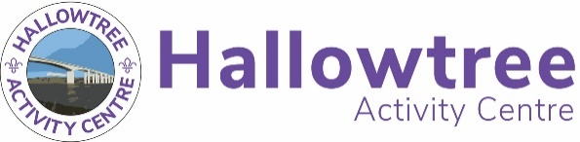

Activity Booking Request Form
Please use this form to book an activity or multiple activities for your visit.
Enter the times you wish for your activities to start and finish, the approximate number of participants per session, and whether you need a Hallowtree instructor.
Please note, most activities have a session time of 1.5 hours. Check the Hallowtree website for details.
Once you have completed this form, please email it to bookings@hallowtree.org.uk.

Group Info
Group Name |  | Date(s) of Visit
Participant Age(s) |  | Type of Event
Event Leader Name |  | Event Leader Phone

Example
Date | Activity | Session 1 Time | Session 2 Time | Session 3 Time | Session 4 Time | Session 5 Time | Session 6 Time | Approx. Number Per Session | HT Instructor Needed?
Sat 10th March | Climbing | 0900 | 1030 | 1200 | 1330 | 1500 |  | 12 | Y
Sat 10th March | Archery | 0900 | 1030 | 1200 | 1330 | 1500 |  | 12 | Y
Sun 11th March | Go-Karts | 1100 |  |  |  |  |  | 10 | N
Sun 11th March | Air Rifles | 1000 | 1400 | 1800 |  |  |  | 12 | Y

Your Booking Request
Date | Activity | Session 1 Time | Session 2 Time | Session 3 Time | Session 4 Time | Session 5 Time | Session 6 Time | Approx. Number Per Session | HT Instructor Needed?
Please continue on a separate sheet if necessary.

If you have any questions around completing this form, please email bookings@hallowtree.org.uk.

